**Advanced Software Engineering**

**Assignment - Lab 10**

Team – 1_1

**Chennapareddy Ravindra Reddy (16296266)**

**Yannamaneni Pavan Kumar (16301933)**

# Create AWS User

An AWS Identity and Access Management (IAM) user is an entity that we create in AWS to represent the person or application that uses it to interact with AWS.

## Creating IAM User:

We need to follow below steps to create the IAM users.

1. Sign into the AWS management console and open the IAM console at

<https://console.aws.amazon.com/iam/>

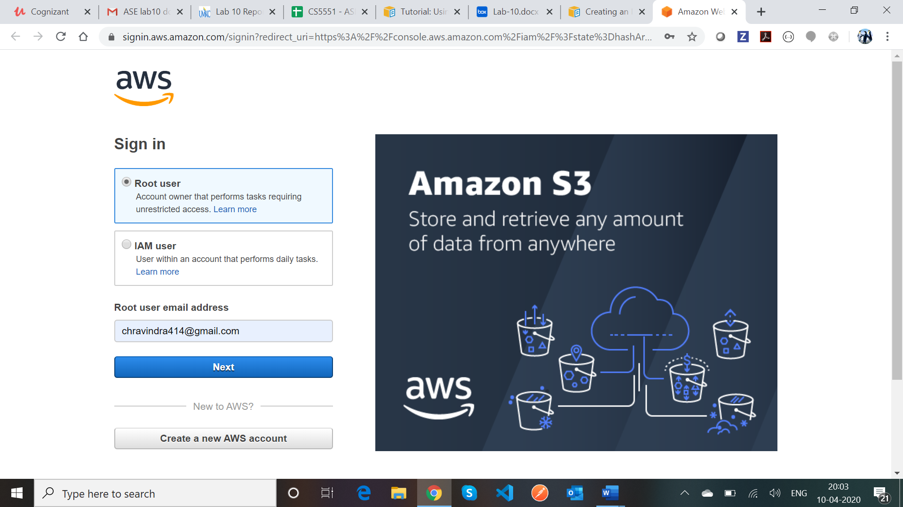

1. In the navigation pane, choose **Users** and then choose **Add user.**

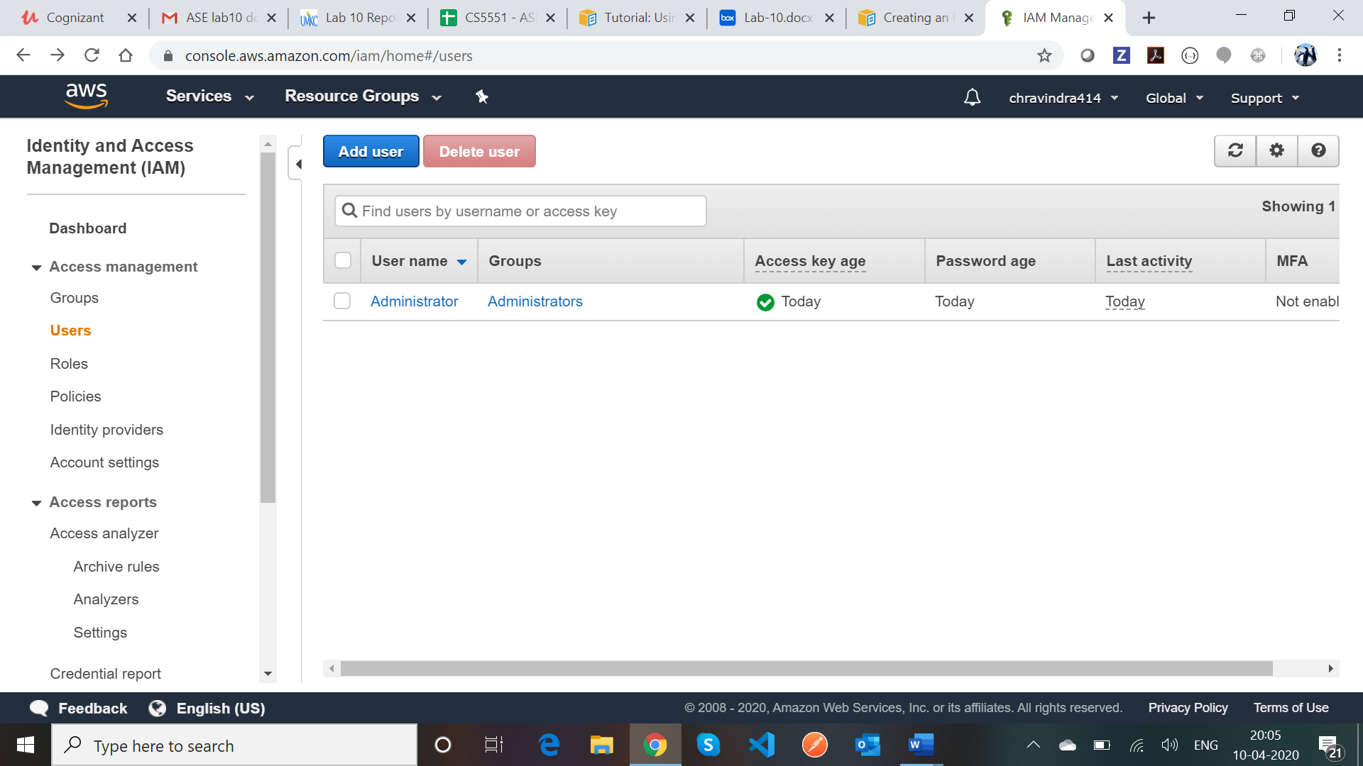

1. We can enter the username for the user and we can add multiple users at a time. Select the programmatic access and AWS management console access and choose custom password for the console password option. And we can uncheck the require password reset to avoid changing password on sign in every time.

Once we are done with the changes, click on Next permissions.

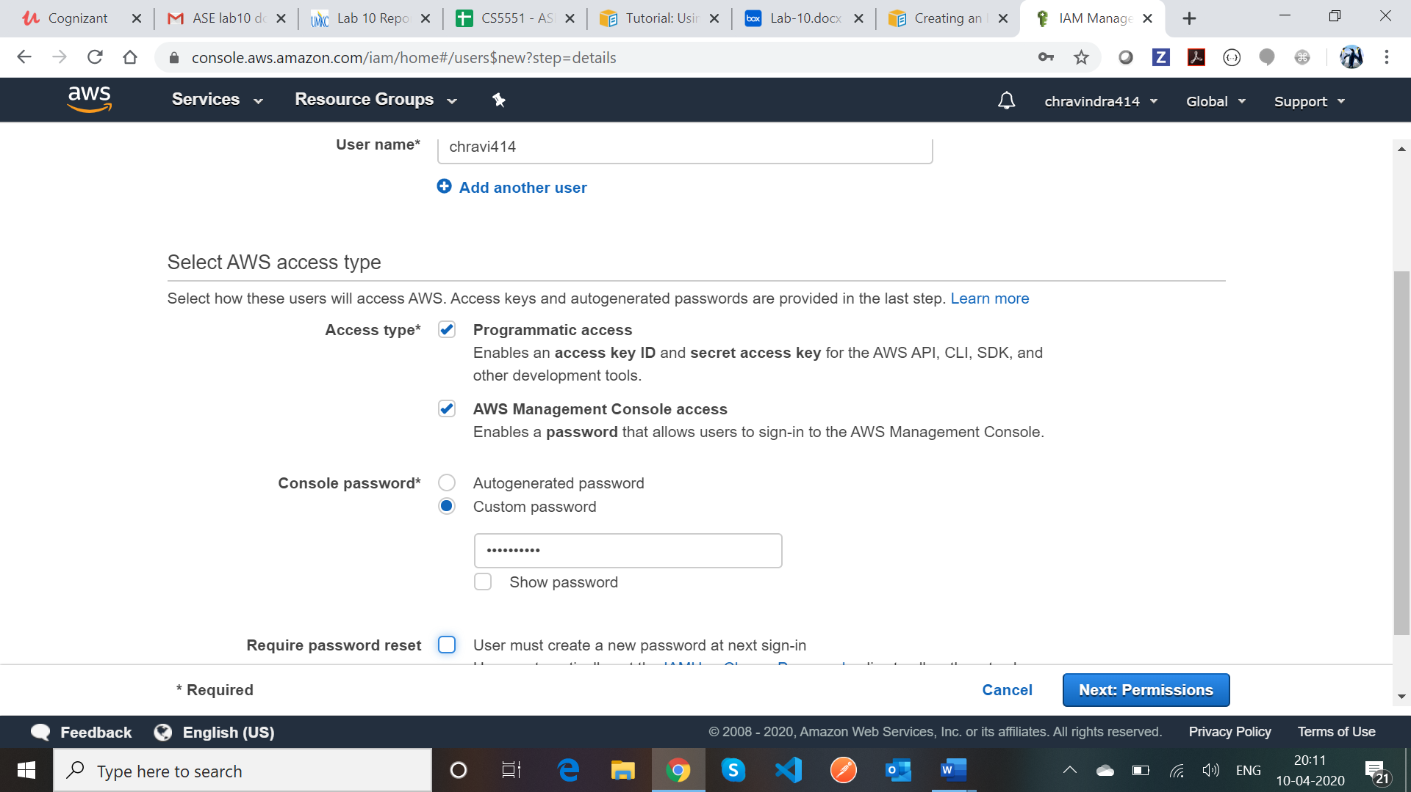

1. On the set permissions page, we can assign permissions to the new user and we will have three options like Add user to group, Copy permissions from existing user and attach existing policies.

We can create a Group and assign permissions to the group and later we can add the user to the group. And click on the Next Tags.

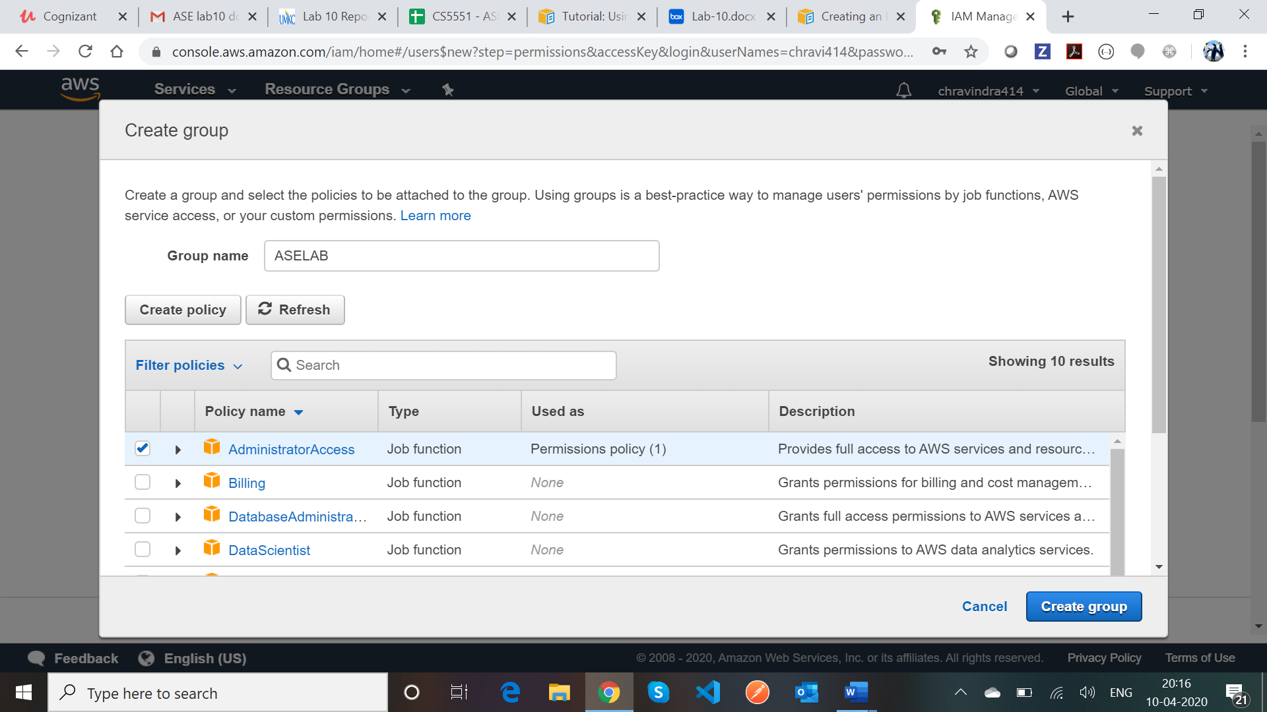

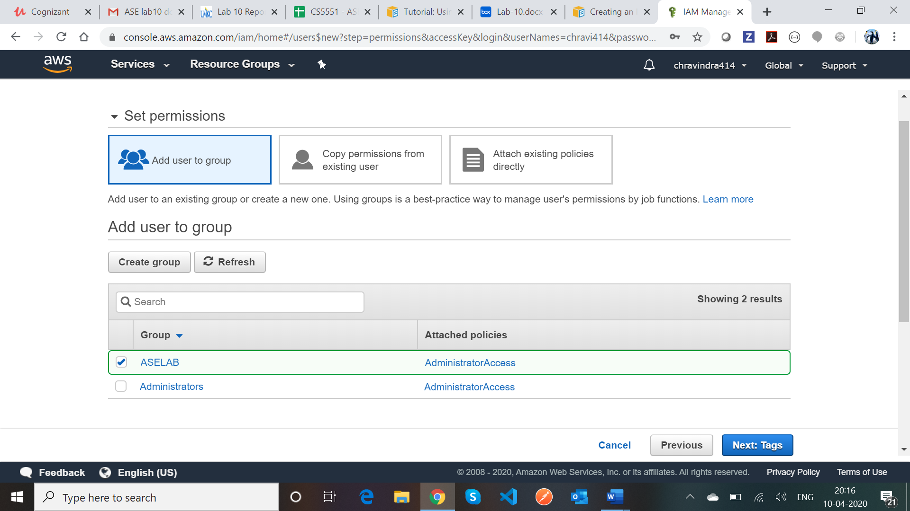

1. We can add the metadata to the user by attaching tags as key-value pairs and choose next review to see all the choices we made till now. Once the changes are reviewed, we can click on Create User.

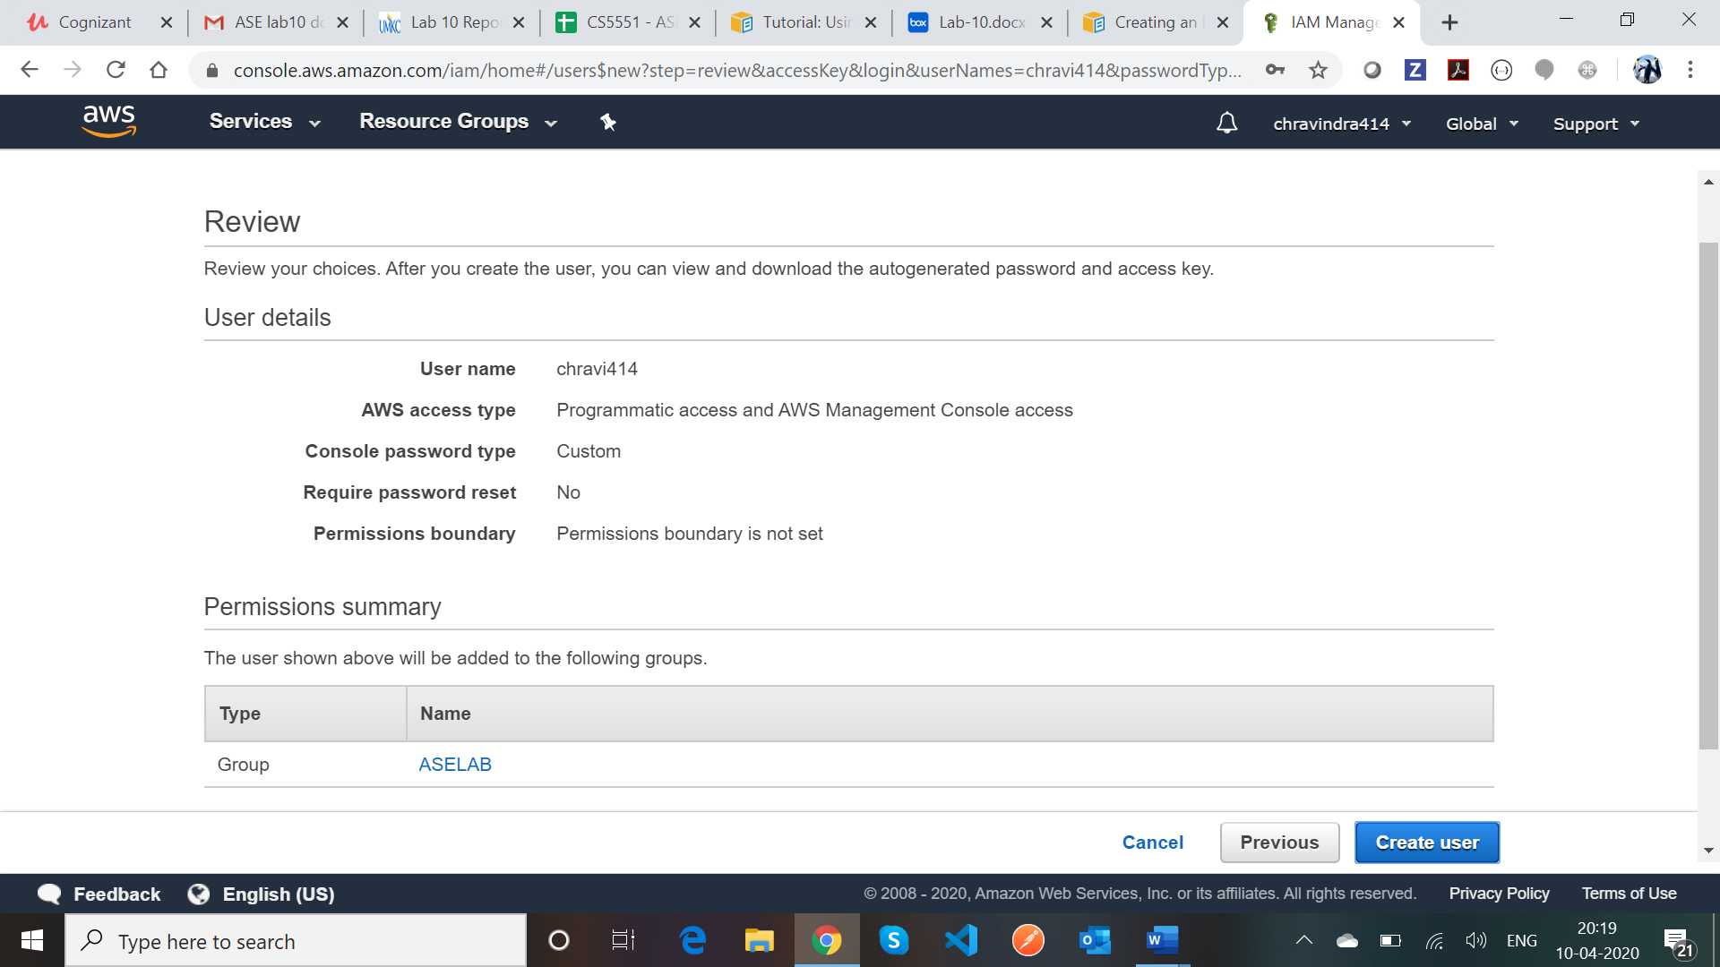

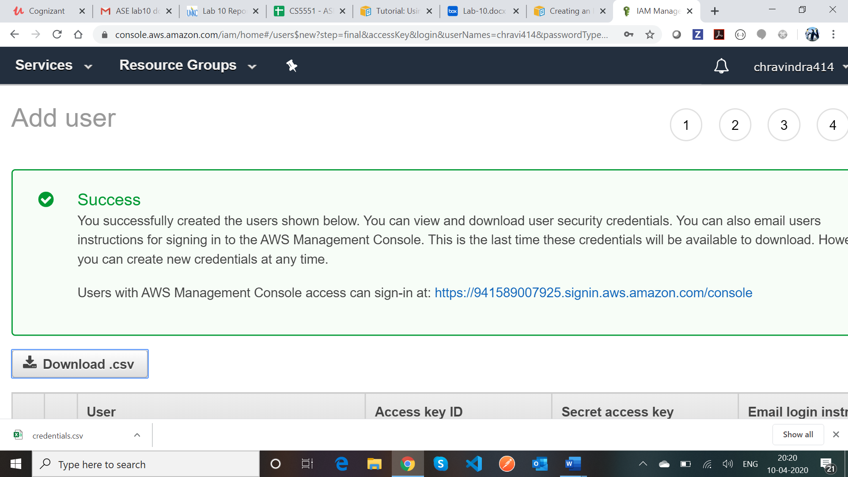

On creating the User, we will get the Access key ID’s and secret access keys, we can download the files for future use.

# Install AWS CLI

This section explains how to install the AWS CLI version 2 on Windows.

1. We need to download the AWS CLI version 2 using the MSI installer and run the downloaded MSI installer.

Once it is installed, we can confirm the version installed using the command

“aws –version”.

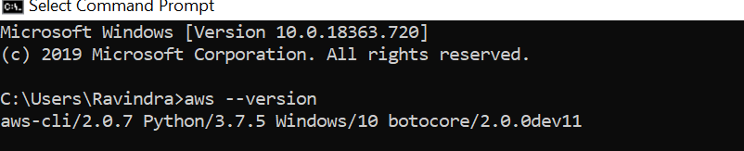

# 3. Configure AWS CLI

This section explains how to configure the settings that the AWS Command Line Interface (AWS CLI) uses to interact with AWS. These include your security credentials, the default output format, and the default AWS Region.

The AWS configure command is the fastest way to set up the AWS CLI installation.

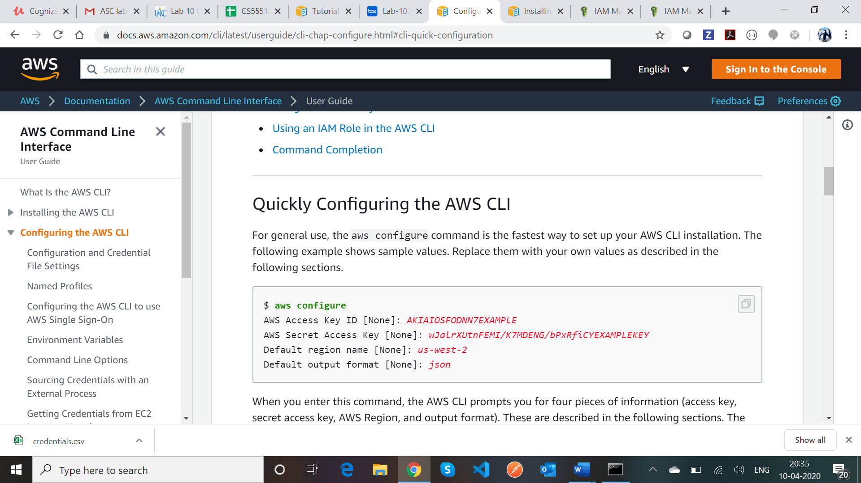

We need to replace the values with our Access key ID, Secret Access key, Default region name and output format.

